**To Discuss:**

**Site:** SSS048 S29

**Notes:** Good DO curve, good model vs observed fit no correlation between K600, ER and GPP

**Overall evaluation by VGC**: Good estimates

**Site:** SSS046 S22RR

**Notes:** Weird DO values at the end of the deployment, water depth drops quite a bit at the end, did the sensor come out of the water? Positive ER and neg GPP at the end (not good). Good correlation between ER and GPP and K600

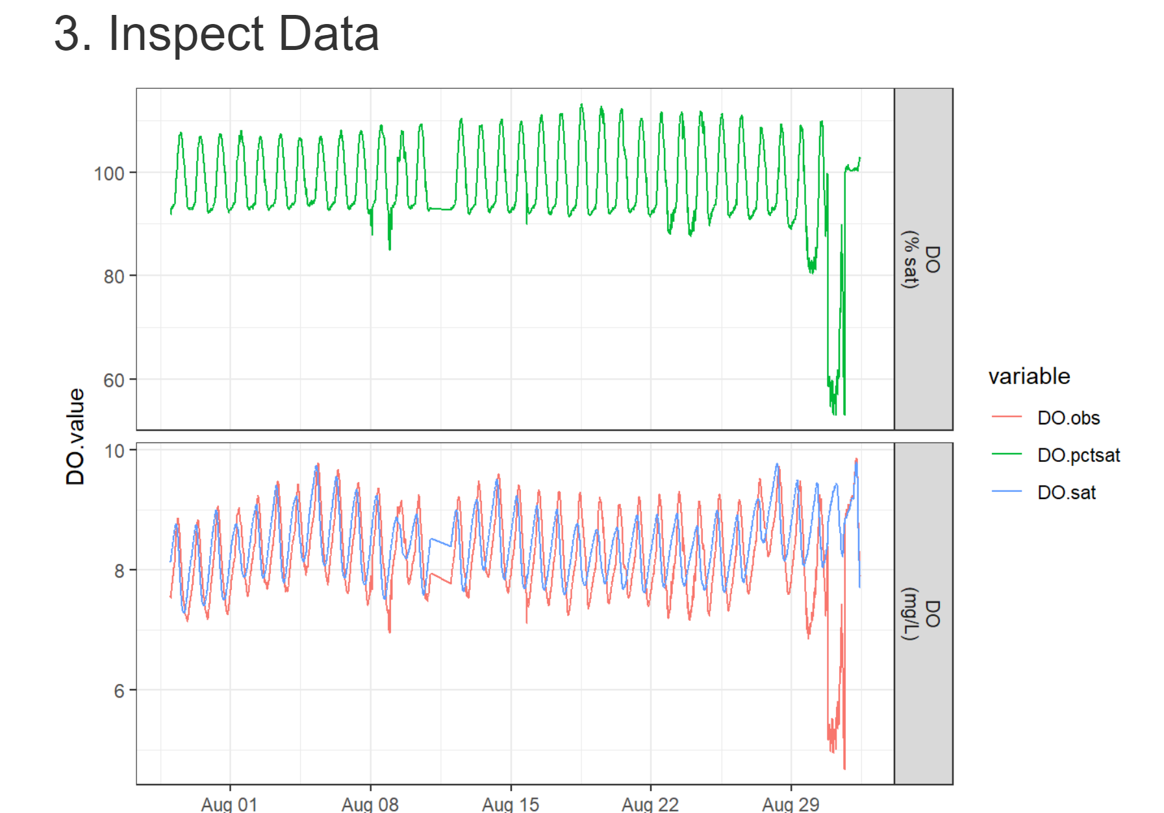

**Overall evaluation by VGC:** DO data needs to be cleaned up and **model needs to be run again.**

**Site:** SSS044 S02

**Notes:** DO always over saturation, is this normal or expected? Overall seems good connection between modeled vs observed results. No correlation between K600 and ER or GPP. More variability in K600 at the end of the months

**Overall evaluation by VGC:** Good estimates but double check with Bob

**Site:** SSS043 S11

**Notes:** DO mostly over saturation. Overall seems good connection between modeled vs observed results. Strong correlation between K600 and ER not for GPP

**Overall evaluation by VGC:** Good estimates but only for mean values

**Site:** SSS042 S51

**Notes:** Most ER values are positive **(red flag)**

**Overall evaluation by VGC:** Needs Bob

Action check calibration.

Make interactive plot for model fits and check in with Bob

Rerun this with relaxed pooling

K600_daily_meanlog_sdlog=0.7

Spread always 0.7

How much are you going to allow sigma to vary from day to day 2% variation

K600_daily_sdlog_sigma=0.02

Change to 0.1 and re-run the model. See what it does I don’t want you to vary much from day to day

It light want o vary if it is not abl it wil tale it on the respiration

**Site:** SSS041 S49R

**Notes:** Good DO curve, good model vs observed fit no correlation between K600, ER and GPP

**Overall evaluation by VGC**: Good estimates

**Site:** SSS040 S54

**Notes:** Most ER values are positive **(red flag)**

**Overall evaluation by VGC:** Needs Bob

Action: Check calibration getting a 5% swing in the DO during the day that is good gas exchange is high above 35 per day this puts into bubble mediated gas exchange zone Amber nat geo 2019

Site is probably very bubbly it will squeze the water above saturatutation Hall 2015

Look at day by day model fits

Try the pooling but not sure

**Site:** SSS039 S37

**Notes:** Overall seems good connection between modeled vs observed results. Strong correlation between K600 and ER less strong but significant with GPP. Daily mean K600 ranges from 20-40

**Overall evaluation by VGC:** Good estimates but only for mean values

**Site:** SSS038 S38

**Notes:** DO values are lower (6-2.5), yet ER is not super high. Model vs observed are not great **(red flag)**. Correlations between K600 and ER and GPP are very scattered. K600 very low

**Overall evaluation by VGC:** Needs Bob

Calculate DO at 18 and at 15 need to see a if something happened in the DO.sat

Not possible for the model to think is 4 and the Raymond says is really high. There is something very strange. If this site is really steep and bubble then there is no way for it to estimate gas exchange of 4 we might have to fit the model with different prior probabilities and see what happens look at the DO data and see they are peaking at solar noon and when the model and data are coming up and data increasing in the middle of the night

By looking at the pictures we can see that the stream is very bubbly and steep so that might be the issue with the model

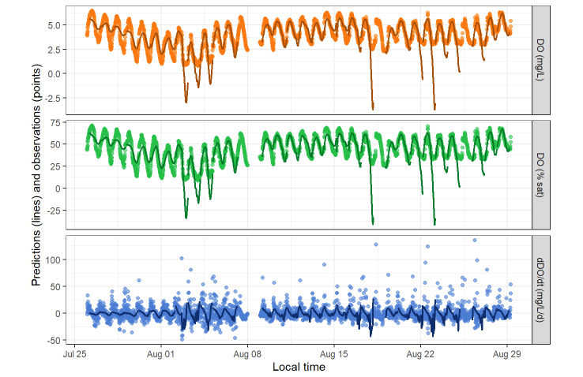 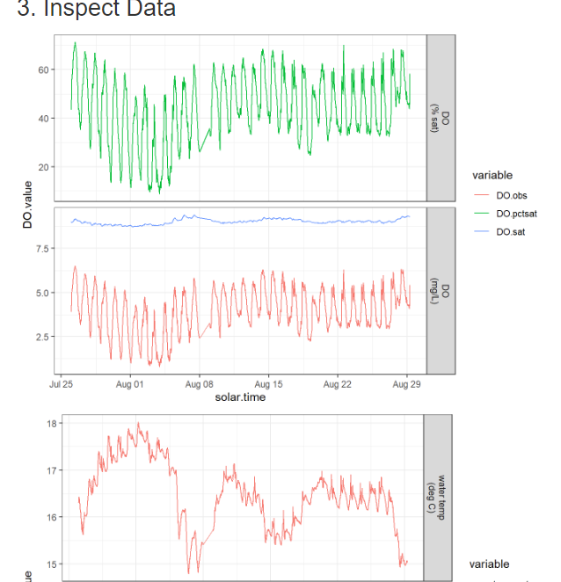

**Site:** SSS037 S39

**Notes:** Good DO curve, good model vs observed fit no correlation between K600, ER and GPP

**Overall evaluation by VGC**: Good estimates

**Site:** SSS036 W10

**Notes:** Good DO curve, good model vs observed fit no correlation between K600, ER and GPP

**Overall evaluation by VGC**: Good estimates

**Site:** SSS035 S17R

**Notes:** Good DO curve, good model vs observed fit no correlation between K600, ER and GPP

**Overall evaluation by VGC**: Good estimates

**Site:** SSS034 S18R

**Notes:** DO over saturation. Strong correlations between ER/GPP and K600. ER values are positive **(red flag)**

**Overall evaluation by VGC:** Needs Bob

Check calibration and check bubbles.

It is ingnoring the prior

There is a lot of variability in K600

DO is always over saturation so we would expect to have positive ER

21% variability in the log

Stdv ~ 0.1

See if there is any co-variance between the steep sites and the propensive ti get positive ER the very bubbly sites have positive ER

Check the calibration by hand and the correction factor and look if we have corrected on the saturation

**Site:** SSS032 C21

**Notes:** Good DO curve, good model vs observed fit no correlation between K600, ER and GPP

**Overall evaluation by VGC**: Good estimates

**Site:** SSS031 S47R

**Notes:** DO mostly oversaturated, high respiration but equally high GPP. Good mode vs observed fit. Strong correlation K600 and ER not for GPP. K600 ranges from 25-40

**Overall evaluation by VGC:** Good estimates for mean values but double check with Bob

**Site:** SSS030 S43

**Notes:** DO saturation reaches 130% (is this normal temperatures are 15-22 C). Good mode vs observed fit. Significant but weak correlation K600 and ER not for GPP. K600 has an outlier? At 14

**Overall evaluation by VGC:** Good estimates for mean values but double check with Bob

**Site:** SSS029 S41R

**Notes:** Check DO curve with Bob, good model vs observed fit no correlation between K600, ER and GPP

**Overall evaluation by VGC**: Good estimates if DO is good

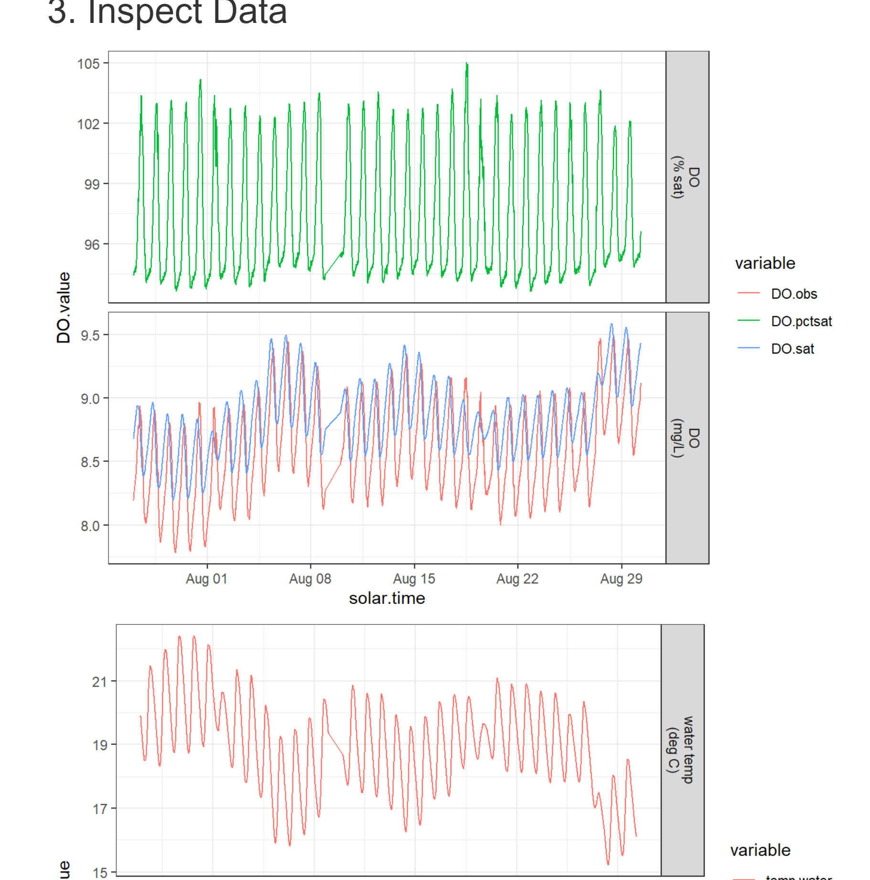

**Site:** SSS028 S42

**Notes:** Couple of days where DO drops pretty low, keep days? ER values are positive **(red flag)**

**Overall evaluation by VGC:** Needs Bob

Model and the timing of metabolism are in 2 different places look at the data and the model fits when is the DO peaking and when is it rising up based on light and time

Remove the 4ish days where the DO drops a lot and see if there is a weird point THE WHOLE DAY

RERUN

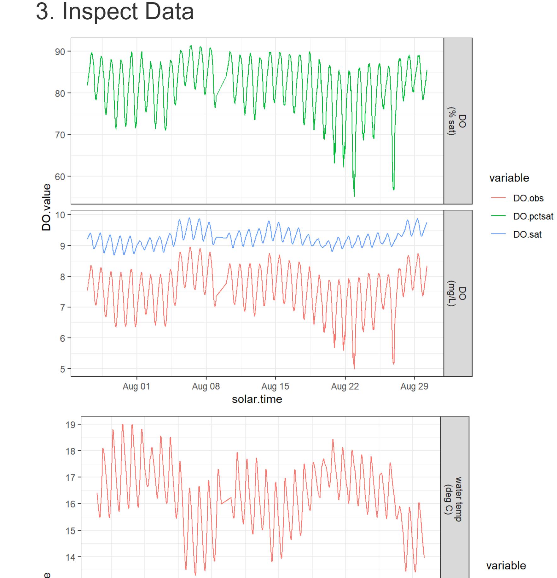

**Site:** SSS026 S36

**Notes:** Overall seems good connection between modeled vs observed results. Significant correlation between K600 and ER and not with GPP. Daily mean K600 are really low (3.8-4.6)

**Overall evaluation by VGC:** Good estimates but only for mean values

**Site:** SSS045 S01

**Notes:** DO over saturation. No correlations between ER/GPP and K600. ER values are positive **(red flag)**

**Overall evaluation by VGC:** Needs Bob

Pooling 0.1 everything else looks good

**Site:** SSS025 S34R

**Notes:** DO as 15 mg/L? big swings in saturation from 50-150%. K600 very low. No correlations between K600 ER/GPP

**Overall evaluation by VGC:** Needs Bob opinion on the DO data

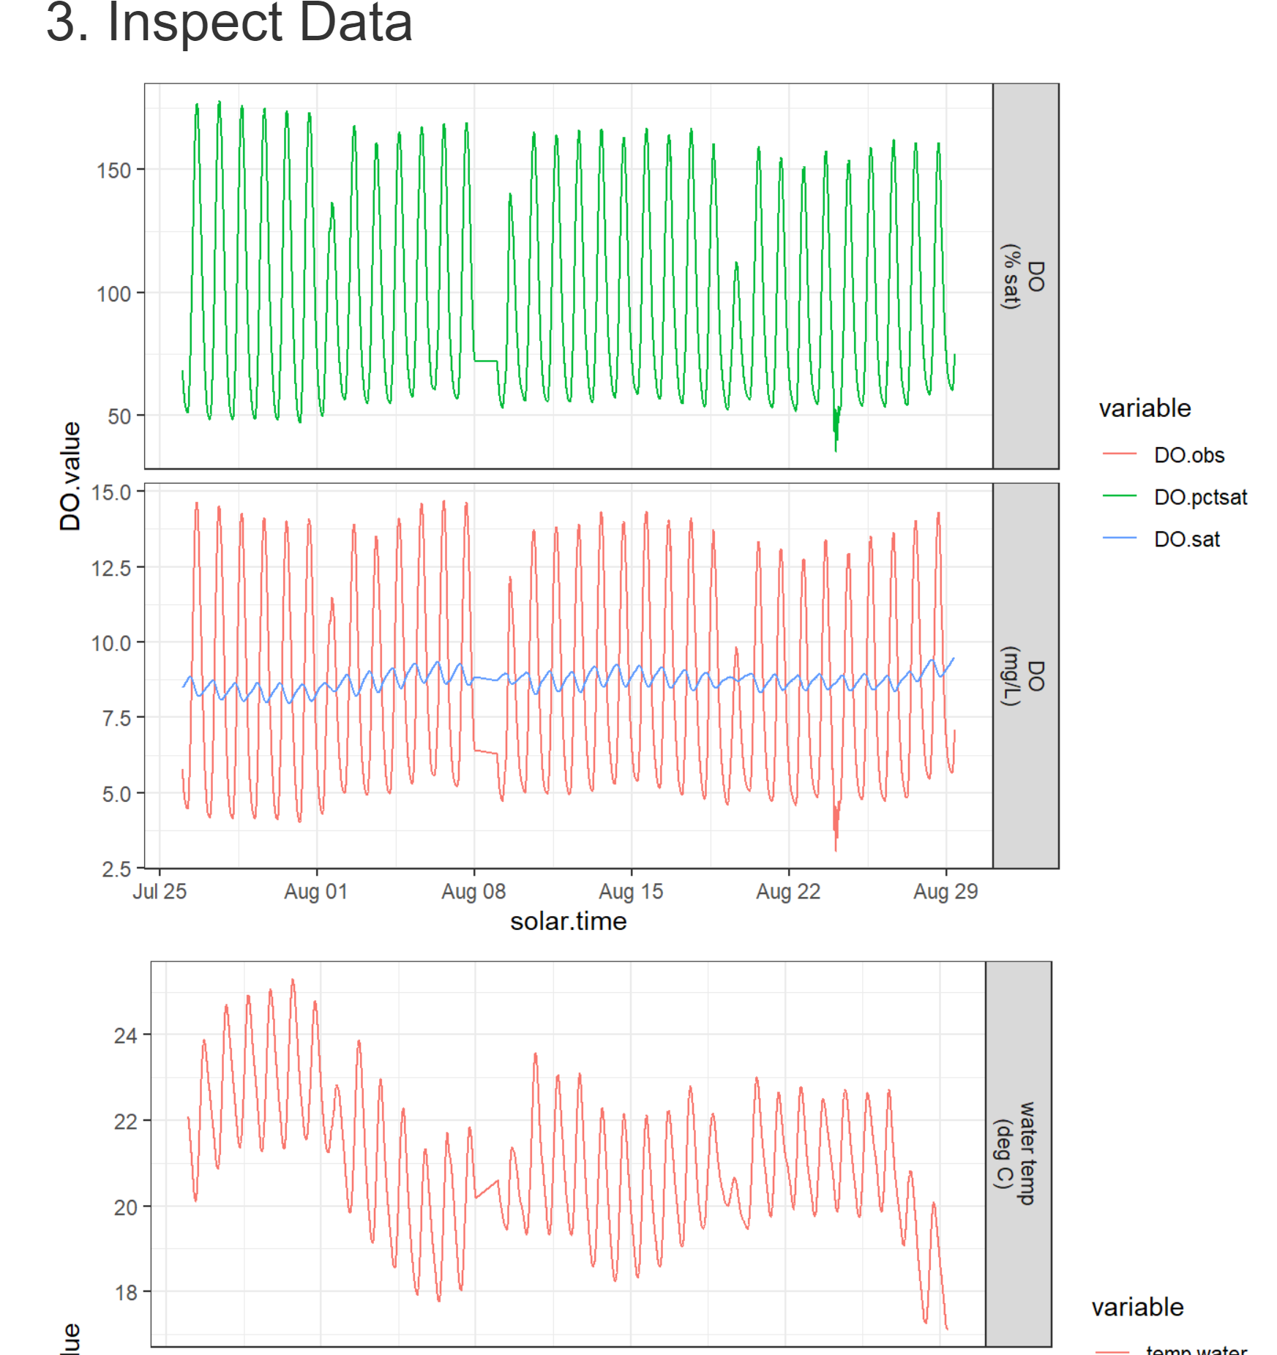

**Site:** SSS024 W20

**Notes:** Overall seems good connection between modeled vs observed results. Strong correlation between K600 and ER and GPP. Daily mean K600 ranges from ~15-30

**Overall evaluation by VGC:** Good estimates but only for mean values

**Site:** SSS023 U20

**Notes:** DO needs double checking. Modeled vs observed data need double checking. No correlation between ER/GPP and K600

**Overall evaluation by VGC:** Needs Bob

Undersaturated conditions but the gas exchange is high

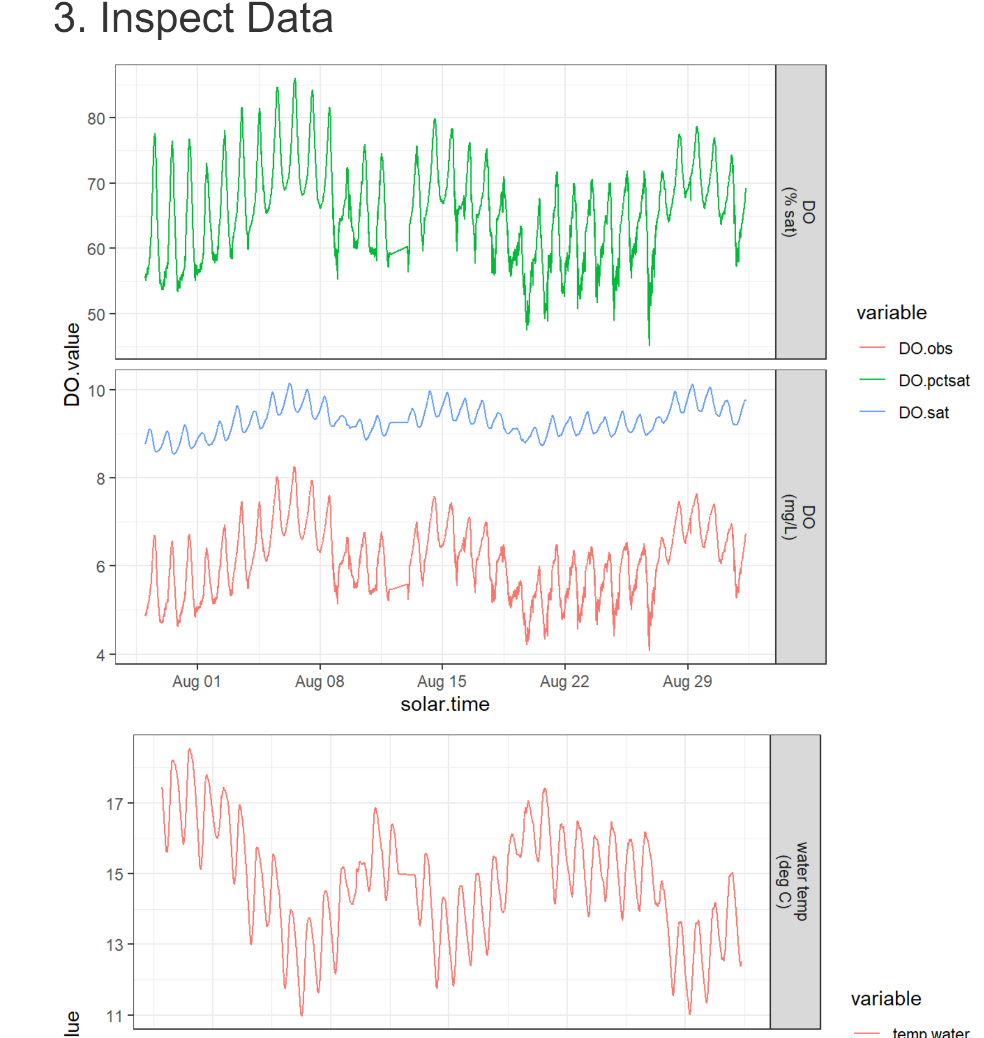 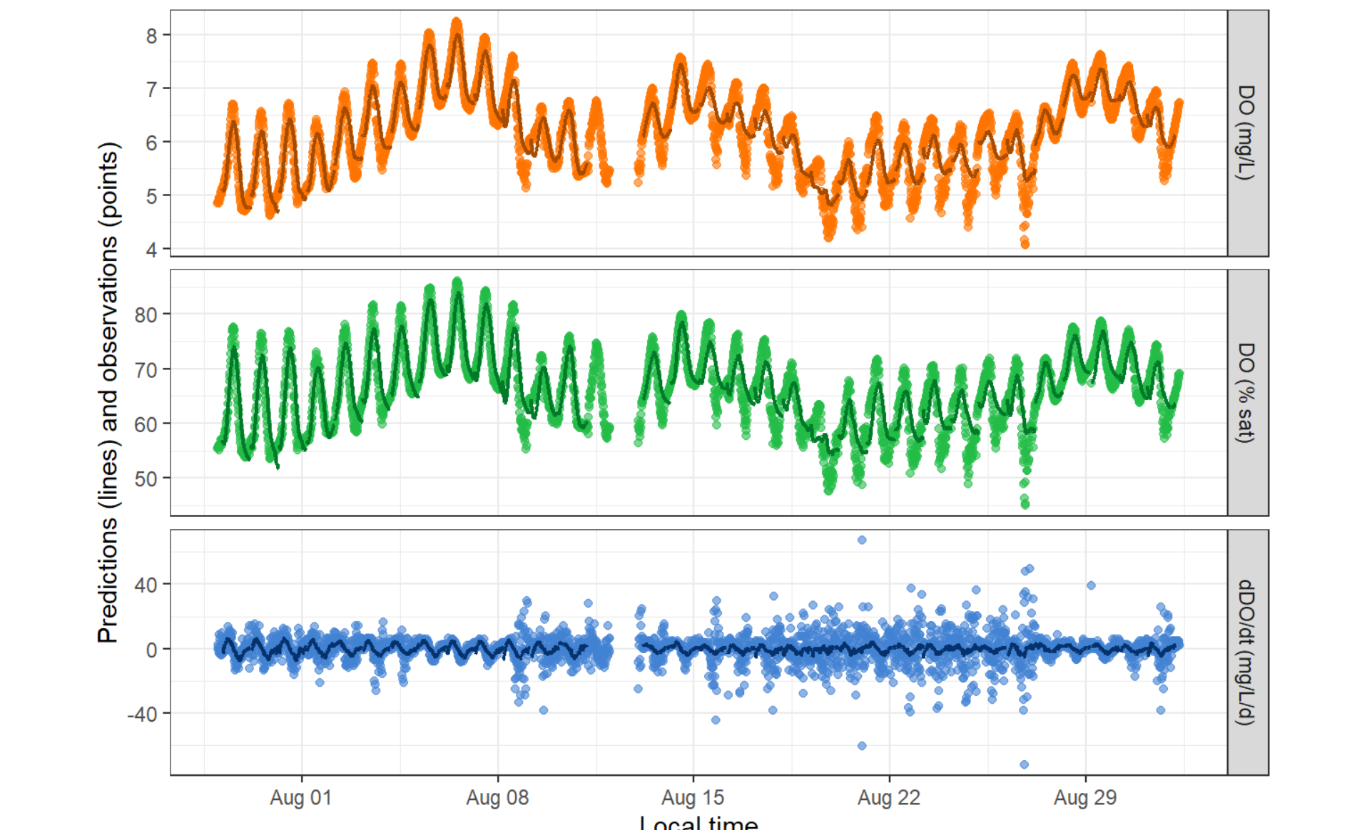

**Site:** SSS022 S15

**Notes:** No correlation ER/GPP and K600. Water depth was very low initially. Some ER values are positive **(red flag)**

**Overall evaluation by VGC:** Needs Bob

**Site:** SSS021 S24

**Notes:** Overall seems good connection between modeled vs observed results. Significant correlation between K600 and ER/GPP. Daily mean K600 18-30

**Overall evaluation by VGC:** Good estimates but only for mean values

**Site:** SSS020 T05P

**Notes:** Overall seems good connection between modeled vs observed results. Significant correlation between K600 and ER/GPP. Daily mean K600 18-35

**Overall evaluation by VGC:** Good estimates but only for mean values

**Site:** SSS019 S03

**Notes:** Overall seems good connection between modeled vs observed results. Significant correlation but weak between K600 and ER not for GPP. Daily mean K600 31-31.8

**Overall evaluation by VGC:** Good estimates but only for mean values

**Site:** SSS018 S08

**Notes:** Big drop in DO saturation and concentration after sapling day, was the sensor swapped? Can we use this data? Check DO curve with Bob, good model vs observed fit . Significant but weak correlation K600 and ER no GPP

**Overall evaluation by VGC**: Good estimates if DO is good

Actions: Trust the PP but not the ER. We could use the 1st half if we can’t figure out what happened with the sensor

Action 2/13/24 The model fits are good, the sensors might have been moved we can keep the data and just average across deployment time.

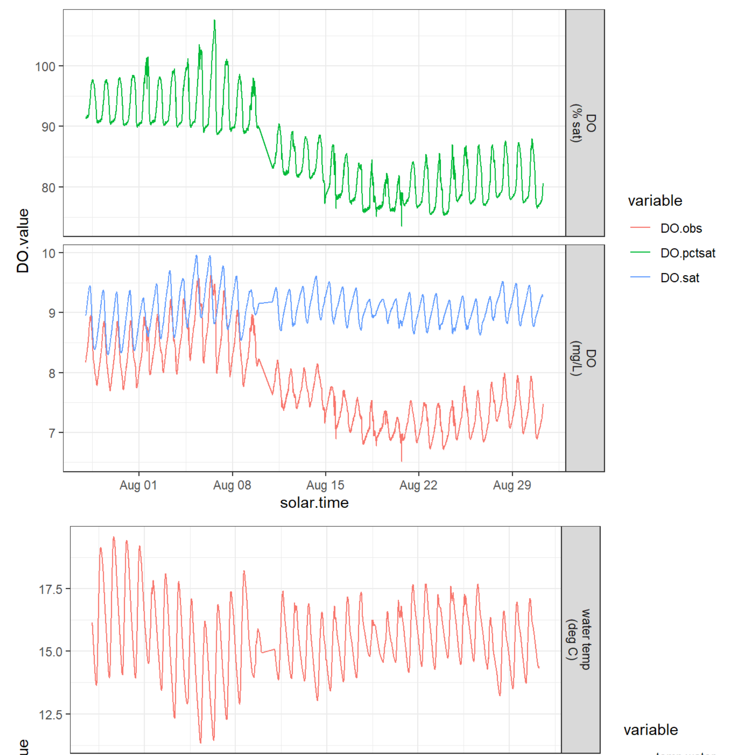

**Site:** SSS017 S58

**Notes:** Overall seems good connection between modeled vs observed results. Significant correlation between K600 and ER/GPP. Daily mean K600 15-30

**Overall evaluation by VGC:** Good estimates but only for mean values

**Site:** SSS016 T42

**Notes:** 2 points with positive ER. Overall seems good connection between modeled vs observed results. Significant correlation between K600 and GPP no ER. Daily mean K600 22-30

**Overall evaluation by VGC:** Good estimates but only for mean values

**Site:** SSS015 T03

**Notes:** Overall seems good connection between modeled vs observed results. Significant correlation between K600 and ER/GPP. Daily mean K600 6-10

**Overall evaluation by VGC:** Good estimates but only for mean values

**Site:** SSS014 T02

**Notes:** Saturation changes from 75% to 150% water temp from 20-26C. Overall seems good connection between modeled vs observed results. Significant but weak correlation between K600 and ER and not with GPP. Daily mean K600 are really low (2.932-2.938). K600 estimate from equations 1.97

**Overall evaluation by VGC:** Good estimates but only for mean values

**Site:** SSS013 T07

**Notes:** Good DO curve, good model vs observed fit no correlation between K600, ER and GPP

**Overall evaluation by VGC:** Good estimates

**Site:** SSS012 S50P

**Notes:** Good DO curve, Double check model vs observed fit. Significant but weak correlation between K600 and ER/GPP

**Overall evaluation by VGC:** Good estimates for mean values

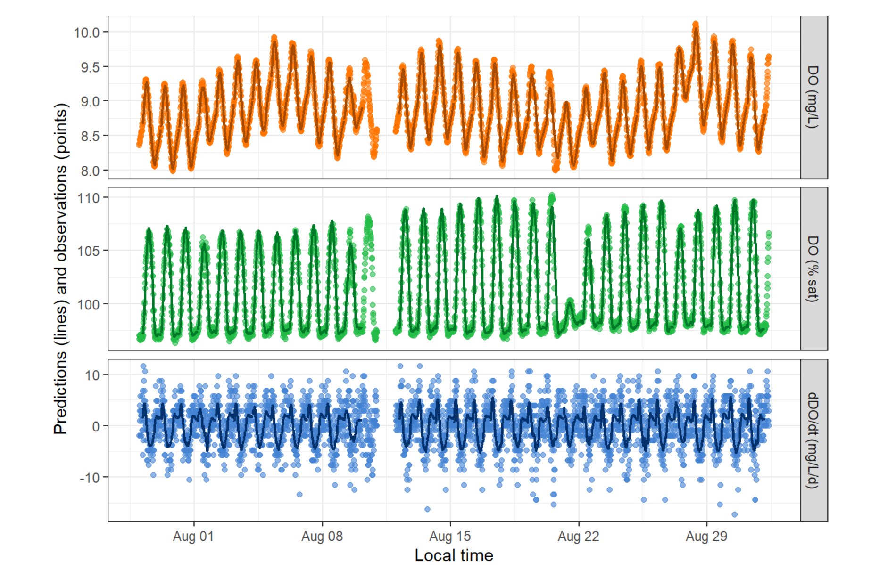

**Site:** SSS011 S04

**Notes:** Good DO curve but larger swings in saturation at the end of the deployment. Good model vs observed fit. Significant and strong correlation between K600 and ER/GPP. K600 ranges from 50-350. Estimate from the equations 1320.34, is this a **red flag**?

**Overall evaluation by VGC:** Good estimates for mean values

10% slope is really steep, double check the slope, not a red flag the site did as expected good estimates we are at the limitis of where it is going to work do not regress GPP and ER

**Site:** SSS010 S10

**Notes:** No correlation ER/GPP and K600. Most ER values are positive **(red flag)**

**Overall evaluation by VGC:** Needs Bob

**Site:** SSS009 S45

**Notes:** Good DO curve. Good model vs observed fit. Significant and strong correlation between K600 and ER/GPP. K600 ranges from 50-100. K600 estimate from equations: 142.99

**Overall evaluation by VGC:** Good estimates for mean values

**Site:** SSS008 S52

**Notes:** Double check modeled vs observed values. No relationship between K60 and ER/GPP.

**Overall evaluation by VGC:** Good estimates as long as plot below looks good.

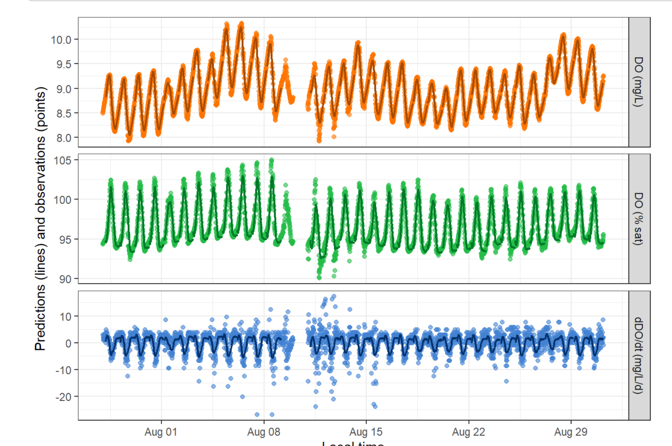

**Site:** SSS007 S53

**Notes:** Higher saturation at the end of deployment. Modeled vs observed not great. Significant ER/GPP and K600. All ER values are positive **(red flag)**

**Overall evaluation by VGC:** Needs Bob

**Site:** SSS006 S56N

**Notes:** Double check DO curve. Significant correlation between K600 and ER/GPP

**Overall evaluation by VGC:** Good estimates for mean values after checking DO

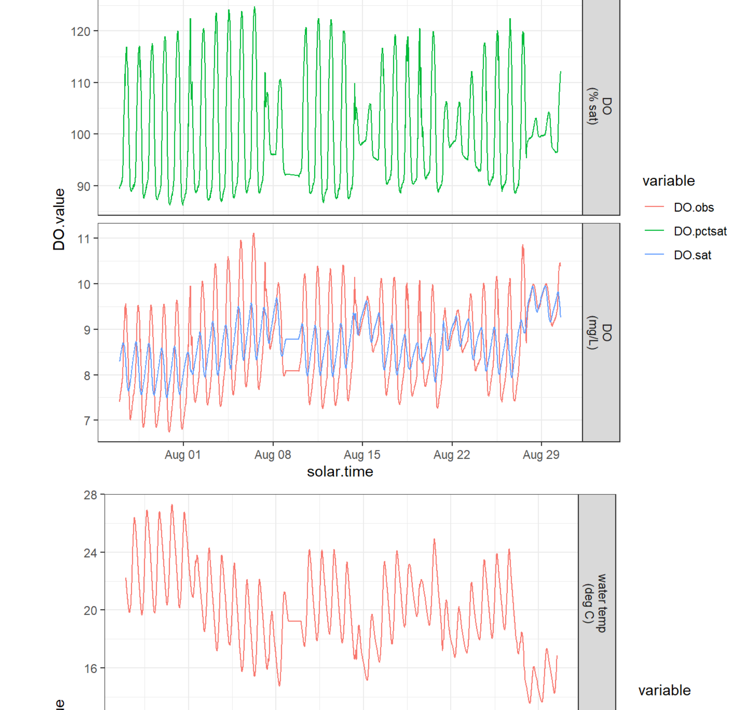

**Site:** SSS005 S57

**Notes:** Bigger swings in saturation at the end deployment. Not great modeled vs observed at the end of deployment **(red flag)**. There is probably an outlier in the K600 values driving correlations. K600 estimate from equations is 17.78 and modeled values range 9.20-9.35.

**Overall evaluation by VGC:** Need Bob.

Need to cut the end of deployment because of biofouling

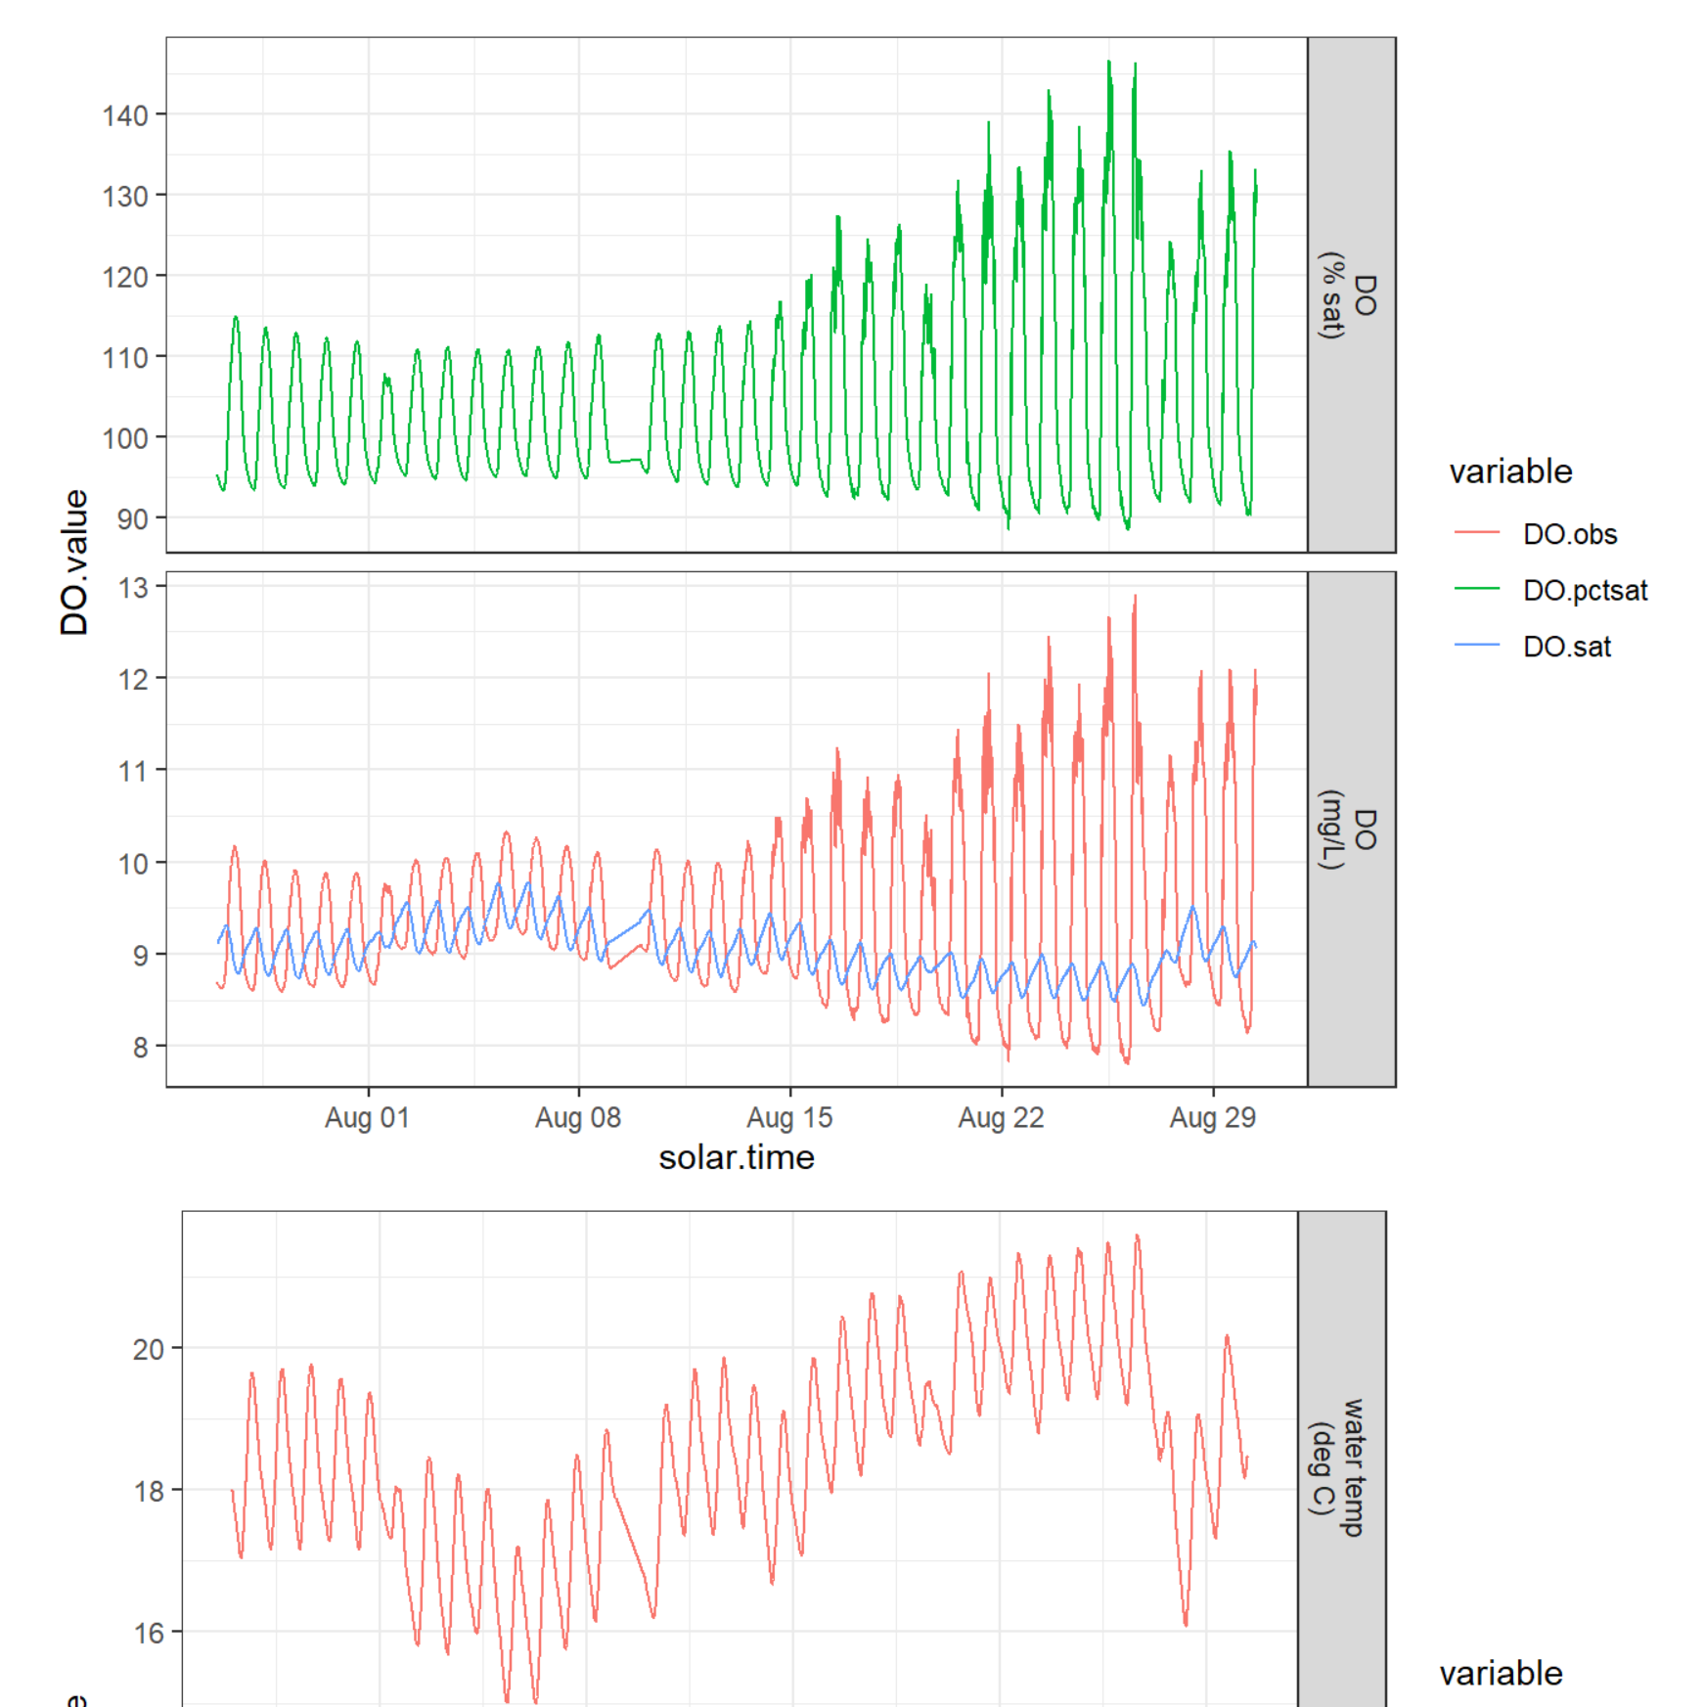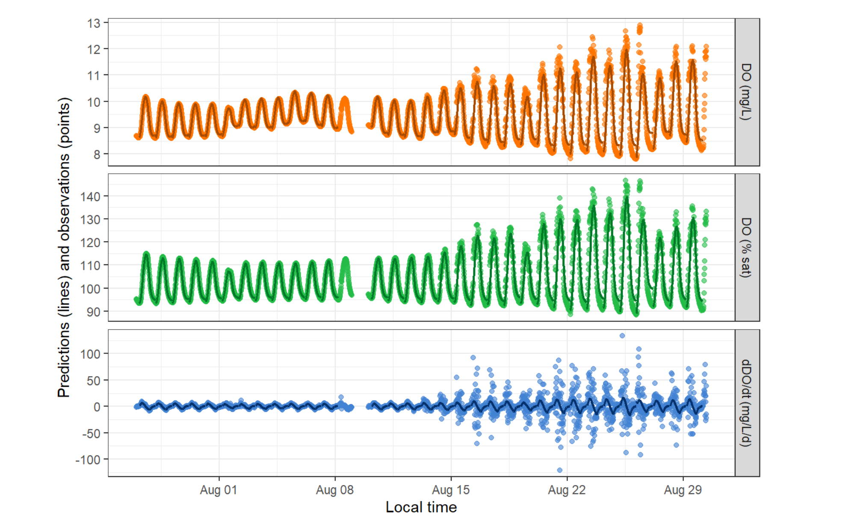

**Site:** SSS003 S31

**Notes:** Double check modeled vs observed values. No relationship between K60 and ER/GPP.

**Overall evaluation by VGC:** Good estimates as long as plot below looks good.

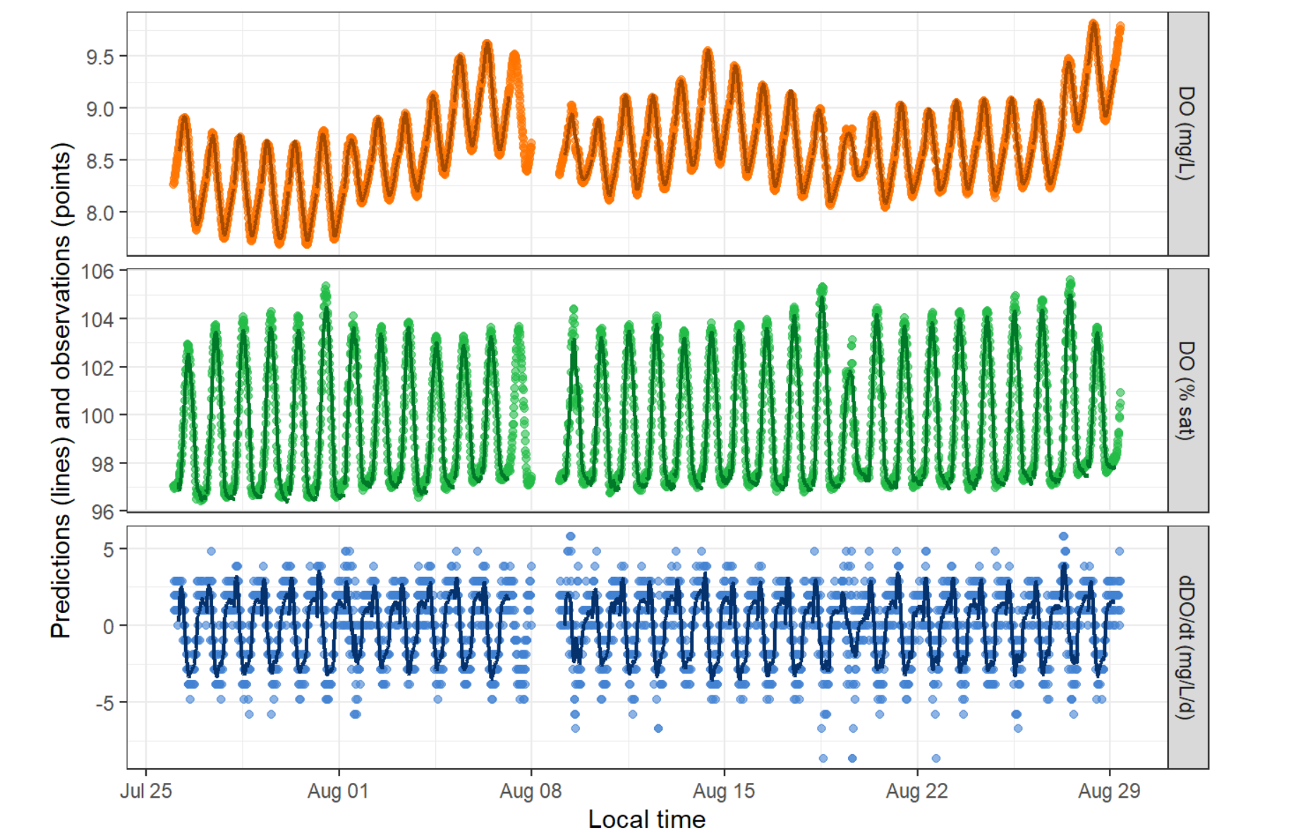

**Site:** SSS002 S30R

**Notes:** Double check modeled vs observed values. Strong relationship between K60 and ER/GPP.

**Overall evaluation by VGC:** Good estimates for mean values as long as plot below looks good.

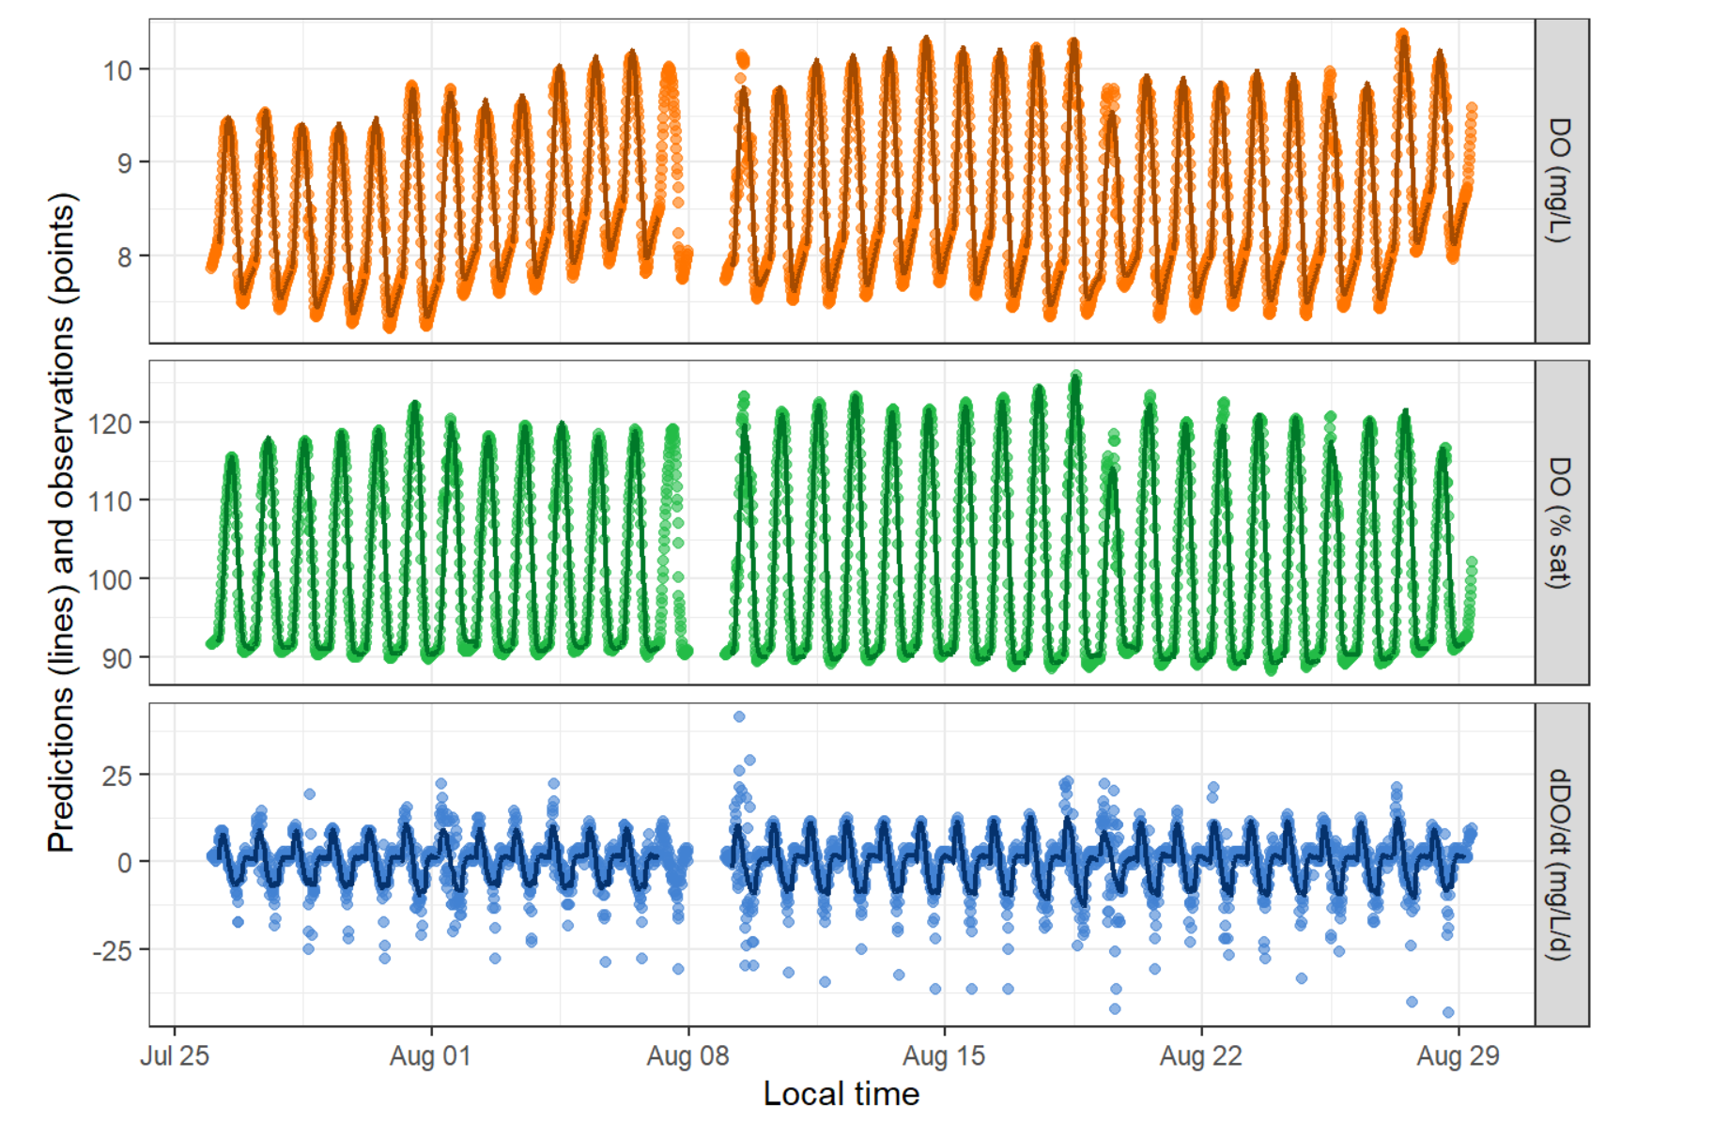

**Site:** SSS027 S32

**Notes:** Double check modeled vs observed values. Strong relationship between K60 and ER/GPP.

**Overall evaluation by VGC:** Good estimates for mean values as long as plot below looks good.

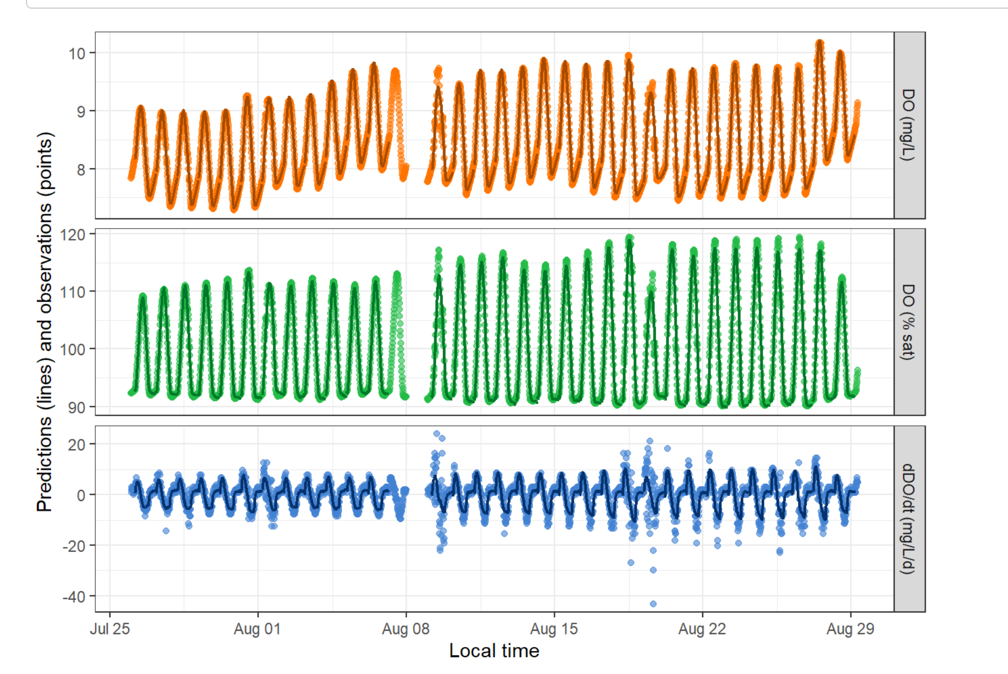

**Site:** SSS047 S23 (run differently than the rest)

**Notes:** Drop in DO as a function of deployment (is this OK?). Double check modeled vs observed. No relationship between K600 and ER/GPP.

**Overall evaluation by VGC:** Needs Bob

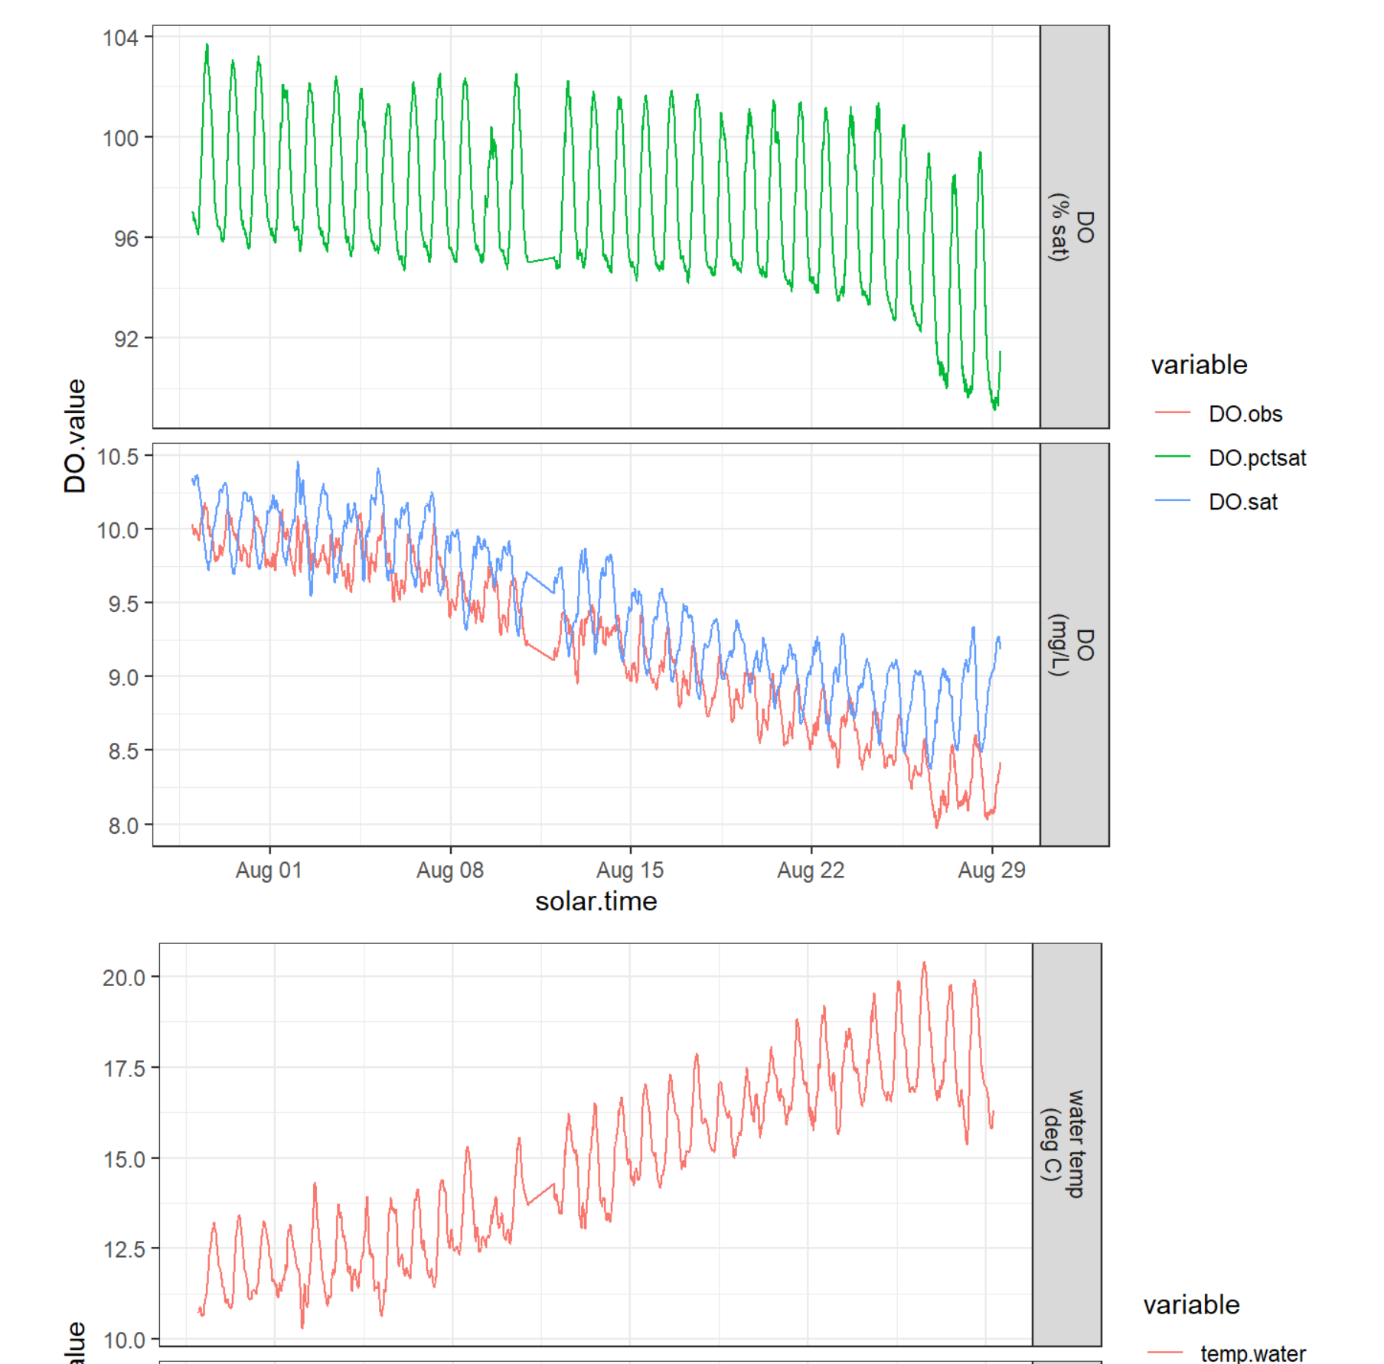 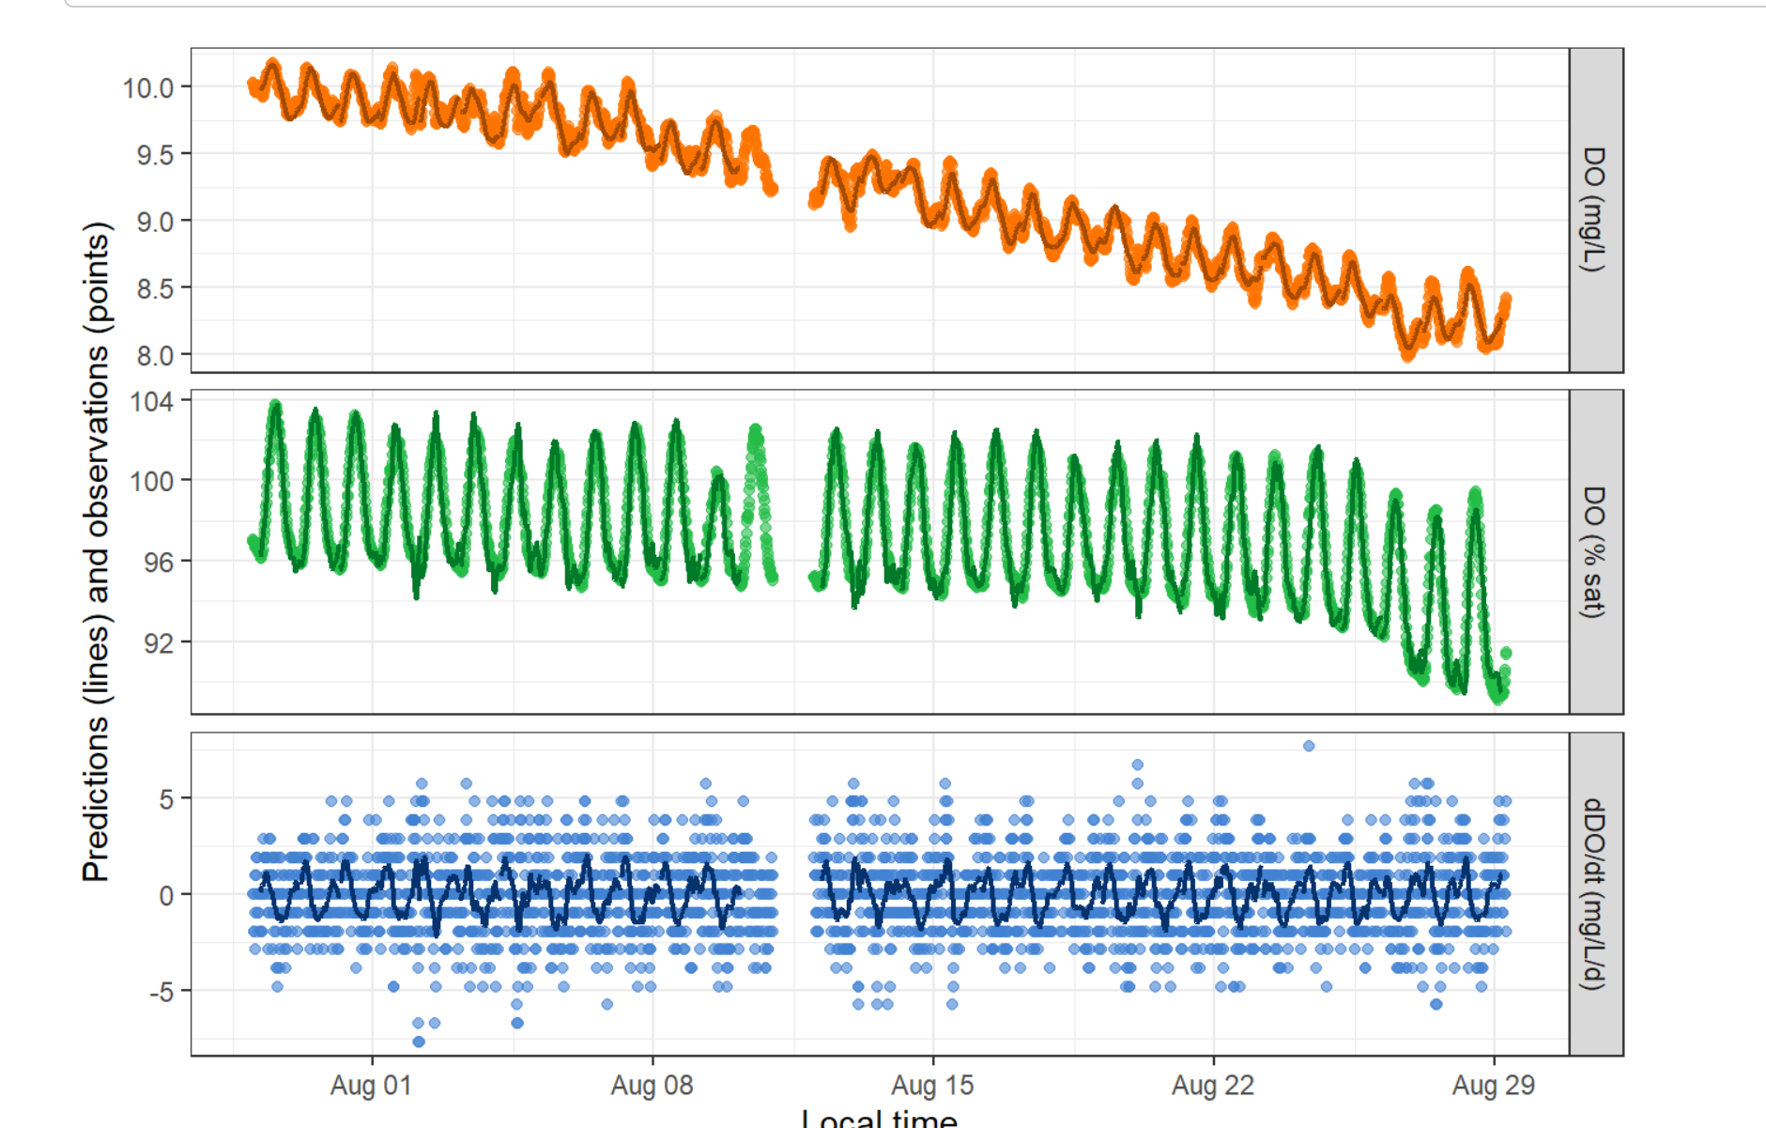

**Site:** SSS033 S48R (run differently than the rest)

**Notes:** Seems a lot of days were removed prior modeling by Matt. Good modeled vs observed. Significant but weak correlation K600 and ER, not for GPP.

**Overall evaluation by VGC:** Good estimates for mean values.

**Site:** SSS004 S55N (run differently than the rest)

**Notes:** Shorter deployment window? Good observed vs modeled. No relationship K600 vs ER/GPP. K600 drops at the end of the deployment and ranges from 25-29. Initial estimate from equations was 231.39.

**Overall evaluation by VGC:** Good estimates

**Site:** SSS001 S63 (run differently than the rest)

**Notes:** Positive ER values before sampling and sensor maintenance **(red flag)**. Not great modeled vs observed values. No relationship between K600 vs ER/GPP. K600 values range from 8.62-8.72. Estimate from equations was 176.1.

**Overall evaluation by VGC:** Need Bob

